

**AI FITNESS TRAINER**

*A project submitted in partial fulfillment of the requirements for the award of the degree of*

***Supervised by:***

*Dr. Mukesh Mann*

***Submitted by:***

*Rohit Raj*

*Branch: CSE*

*Roll No.: 12011035*

**Bachelor of Technology** **in**

**COMPUTER SCIENCE AND ENGINEERING**

**SELF DECLARATION**

I hereby declare that work contained in the project file titled “AI FITNESS TRAINER” is original. I have followed the standards of research/project ethics to the best of my abilities. I have acknowledged all sources of information which I have used in the project.

**Name**: Rohit Raj

**Roll No.**: 12011035

Department of Computer Science and Engineering,

Indian Institute of Information Technology,

Sonipat-131201, Haryana, India.

**CERTIFICATE**

This is to certify that Mr. Rohit Raj has worked on the project entitled “AI FITNESS TRAINER” under my supervision and guidance. The contents of the project, being submitted to the Department of Computer Science and Engineering, IIIT Sonipat, for the award of the degree of B.Tech in Computer Science and Engineering, are original and have been carried out by the candidate himself. This project has not been submitted in full or part for the award of any other degree or diploma to this or any other university.

Dr. Mukesh Mann

Supervisor

Department of Computer Science and Engineering,

Indian Institute of Information Technology,

Sonepat-131201, Haryana, India

**ACKNOWLEDGEMENTS**

We would like to express our special thanks of gratitude to our teacher (Dr. Mukesh Mann) who gave us the golden opportunity to do this wonderful project on the topic AI Fitness Trainer which also helped us in doing a lot of Research and we came to know about so many new things we are really thankful to them. Secondly, we would also like to thank our parents and friends who helped me a lot in finalizing this project within the limited time frame. We are overwhelmed in all humbleness and gratefulness to acknowledge my depth to all those who have helped us to put these ideas, well above the level of simplicity and into something concrete. Any attempt at any level can 't be satisfactorily completed without the support and guidance of my parents and friends. we would like to thank our parents who helped me a lot in gathering different information, collecting data and guiding me from time to time in making this project, despite of their busy schedules, they gave me different ideas in making this project unique. Thanking you,

Arjun Chaudhary, Rohit Raj, Abhishek Kumar Shah

12011048, 12011035, 12011031

**ABSTRACT**

Name of the student: **Rohit Raj**

Roll No.: **12011035**

Degree for which submitted: **B. Tech (CSE)**

Department of **Computer Science and Engineering, IIIT Sonipat**.

Project Title: **AI FITNESS TRAINER**

Name of the thesis supervisor: **Dr. Mukesh Mann**

Month and year of project submission: **October 2021**

Physical activity or exercise can improve our health and reduce the risk of developing several diseases like type 2 diabetes, cancer and cardiovascular disease. Physical activity and exercise can have immediate and long-term health benefits. Most importantly, regular activity can improve our quality of life.

A minimum of 30 minutes a day can allow us to enjoy these benefits.

One shouldn’t be surprised when we say that AI can be an indispensable part of our fitness. In some ways, an AI-driven fitness coach can be better than a human trainer. It has access to more data, knows more exercises, and can track your progress more precisely.

AI Fitness Trainer uses pose estimation running on CPU to find the correct points and using these points we will get the desired angles then based on these angles we can find many gestures including the number of bicep curves, bends etc.

It combines AI-powered motion tracking and personalized training to offer a customized full-body workout featuring a variety of exercises.

|  |  |
| --- | --- |
| AI | Artificial Intelligence |
| 3-D | 3 Dimensional |

**List of Abbreviations**

**Table of Contents**

|  |  |  |
| --- | --- | --- |
|  |  | Pg. No. |
|  | Self-Declaration | **02** |
|  | Certificate | **03** |
|  | Acknowledgment | **04** |
|  | Abstract | **05** |
|  | List of Abbreviations | **06** |
|  |  |  |
| CHAPTER 1 | | |
| 1. | Introduction | **08** |
| 2. | Problem Outline | **10** |
| 3. | Project Objectives | **11** |
| 4. | Project Methodology | **12** |
| 5. | Project Implementation | **13** |
|  |  |  |
| CHAPTER 2 | | |
| 1. | Introduction | **15** |
| 2. | Working | **16** |
| 3. | Conclusion | **18** |
|  |  |  |

**CHAPTER I**

1. **INTRODUCTION**

Staying at home for long periods of time can become boring, especially when most fun activities are done outdoors. Still, this is not an excuse to be unproductive and the extra available time is an excellent opportunity to work on your own health. Typical gyms come with a variety of equipment and trainers who can tell you what to do. The lack of these in one's home can often be the culprit that stops them from working out. Wouldn't it be great if there existed a personal trainer that could generate workouts for you at home? What if it could also count the repetitions of each exercise so that you can put all your concentration and energy to do one more push up?

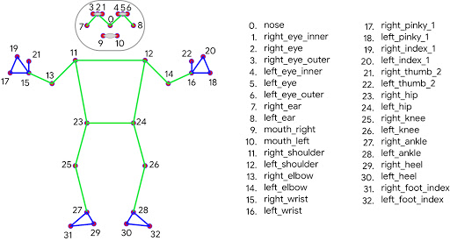Our project that goes by the name AI Fitness Trainer aims to guide everyone to perform exercises properly. It uses OpenCV and Mediapipe to recognize your pose and then determines the angle your biceps, legs etc. are making during the exercise.

It recognizes our pose based on set of points on our body, then takes any three points based on the exercise and determines the angle.

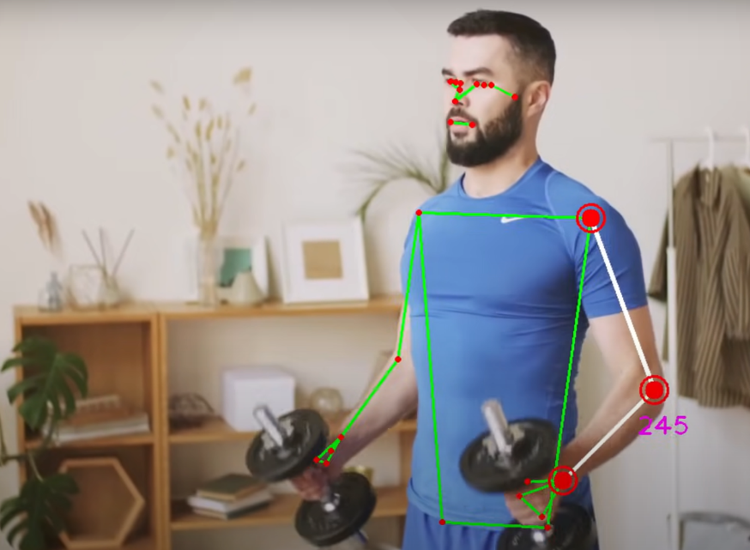

For example, if we are doing bicep curls, then the set of points are (21, 13, 11), on right hand. It then calculates the angle we are making and what is the idle angle for bicep curls. Based on these angles we can also determine many different gestures including the no. of bicep curls.

Similarly, it works for other exercises like push-ups, squats, etc.

1. **Problem Outline**

After coronavirus began to spread its tentacles all over the world, it affected our fitness routine also. People were not able to go to the gym.

Surprisingly, fitness just might be easier to achieve during a global pandemic.

At least, according to a recent survey of 2,000 Americans, 72% of them are finding it easier to maintain their fitness routines now, when they can’t go to the gym, than pre-Coronavirus. Almost half are using fitness apps for the first time, and 56% of people actually don’t plan to buy back into their gym memberships after the current health crisis. And a staggering 80% of men are exercising more now without access to their gyms than before Covid-19, according to data from, an AI-based fitness app with 47 million users in over 160 countries.

If accurate, it indicates we’re getting more fit without the gym than with it.

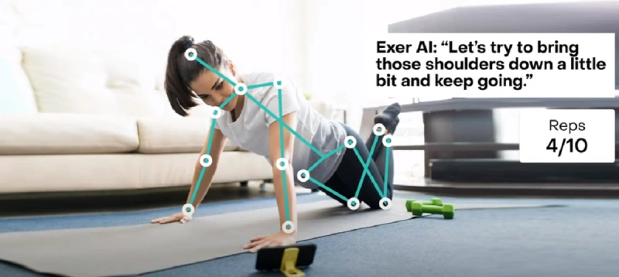

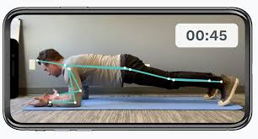

1. **Project Objectives**

The assessment of human poses is sophisticated technology based on computer vision. It's like face recognition for the whole body. Human pose estimation systems detect and evaluate the posture of the human body using three analytical methods:

* Skeleton modelling

This employs key points to depict the human body's skeletal system.

* Contours modelling

This employs the body's raw breadth and extremities to display a person's figure's rectangular border boxes.

* Modelling Volume

This analytical approach employs 3D body scans to capture the body using geometric meshes and forms.

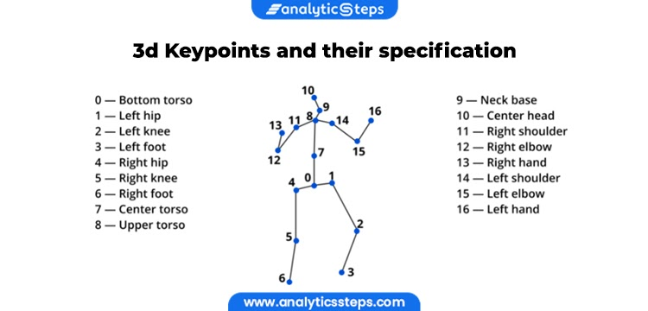

3D human pose estimation technology

1. **Project Methodology**

Hardware Requirements

* PC/Laptop/Smartphone (with camera / webcam)

Software Requirements

* Python 3.8

Python Packages

* CV2
* Mediapipe
* Numpy

It scans the body using the camera and prepares a 3-D mesh diagram of the body. Using this diagram, it determines the pose and calculates the angles different joints are making. We can compare it with the ideal angle that we should make during some particular exercise.

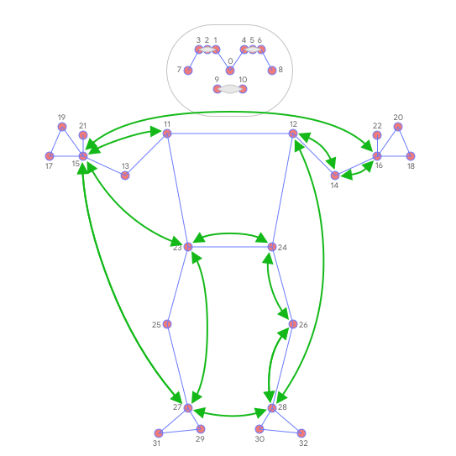

1. **Project Implementation**

We are building an AI Trainer using OpenCV, Mediapipe and Python. We will use the pose estimation running on the CPU to find the correct points and using these points we will get the desired angles. Then based on these angles we find many gestures including the number of biceps curls.

Python is a widely used general-purpose, high-level programming language. It allows programming in Object-Oriented and Procedural paradigms.

The assessment of human poses is sophisticated technology based on computer vision. It's like face recognition for the whole body. Human pose estimation systems detect and evaluate the posture of the human body using three analytical methods:

* Skeleton modelling

This employs key points to depict the human body's skeletal system.

* Contours modelling

This employs the body's raw breadth and extremities to display a person's figure's rectangular border boxes.

* Modelling Volume

This analytical approach employs 3D body scans to capture the body using geometric meshes and forms.

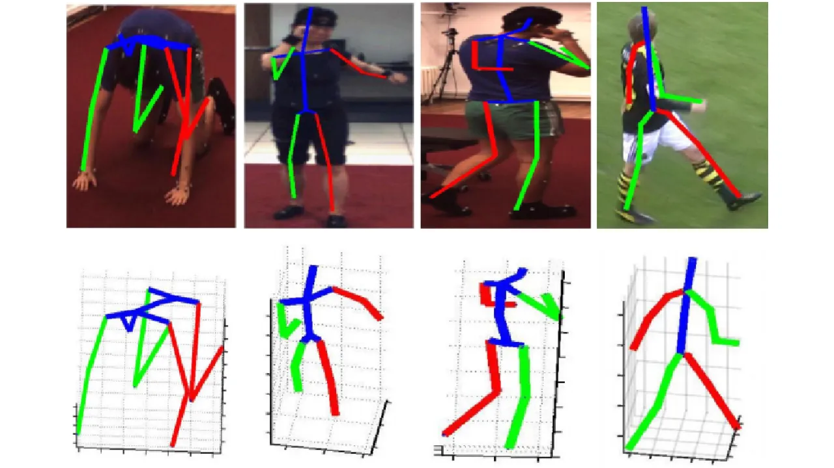

3-D pose recognition using OpenCv & Mediapipe

**CHAPTER II**

1. **INTRODUCTION**

In this chapter we aim to explain the working and methodology of our project **AI Fitness Trainer.**

Our project that goes by the name AI Fitness Trainer aims to guide everyone to perform exercises properly. It uses OpenCV and Mediapipe to recognize your pose and then determines the angle your biceps, legs etc. are making during the exercise.

It recognizes our pose based on set of points on our body, then takes any three points based on the exercise and determines the angle.

For example, if we are doing bicep curls, then the set of points are (21, 13, 11), on right hand. It then calculates the angle we are making and what is the idle angle for bicep curls. Based on these angles we can also determine many different gestures including the no. of bicep curls.

Similarly, it works for other exercises like push-ups, squats, etc.

1. **WORKING**

Our project “AI Fitness Trainer” is made using Python.

* Pose Estimation Module

This program takes 3 points and returns the value of angle that the joints are making, in real time.

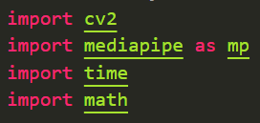

We have imported 4 modules OpenCv, Mediapipe, time & math modules to determine the angles.

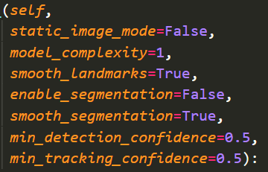Mediapipe uses pose landmarks to determine the various points on the body.

To calculate the angle, it takes only x and y coordinates of 3 points. x and y are variables that it takes from another program and returns the angle. That’s the advantage, that now this PoseModule can be imported to any program.

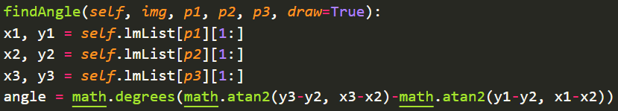

* AI Trainer

This program requires OpenCv, Numpy and time to be imported. We have converted our PoseModule program into a package and imported that also.

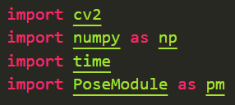

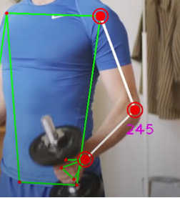 It will take 3 points that have to focussed on a particular exercise, gives it to the PoseModule and returns the value of angle.

angle = detector.findAngle(img, 11, 13, 15) #Left Arm

With simple modifications it also counts the no. of repetations of a particular exercise

1. **CONCLUSION**

Here is the result of our efforts.

